GMV Bus Route System

1st screen (Landing page)

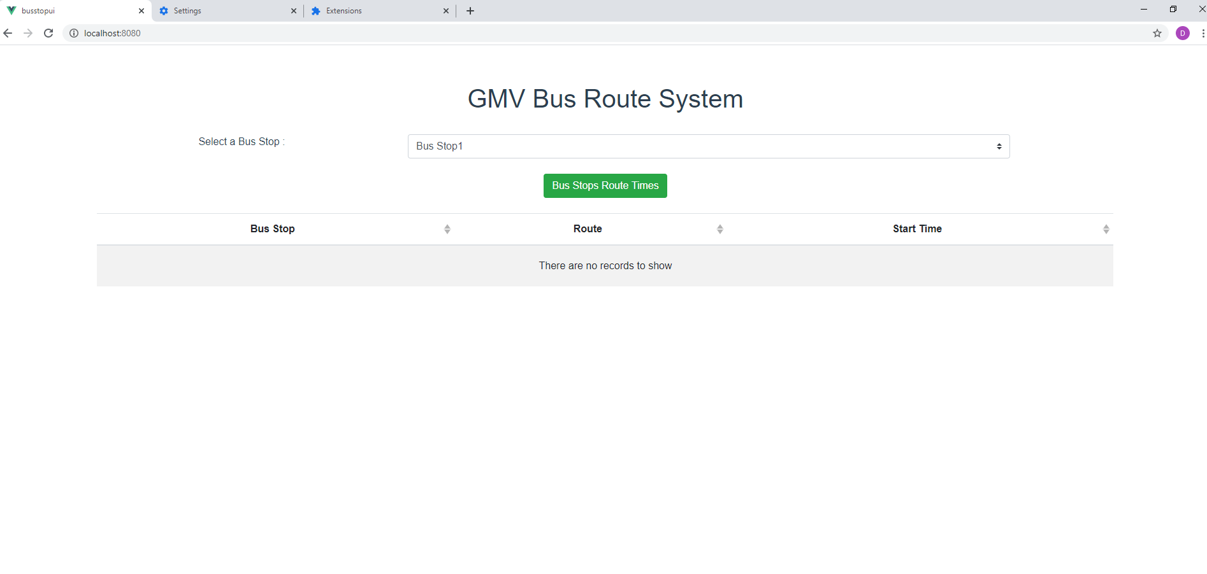

Screen after selected a Bus Stop 1 and then click on the Button.

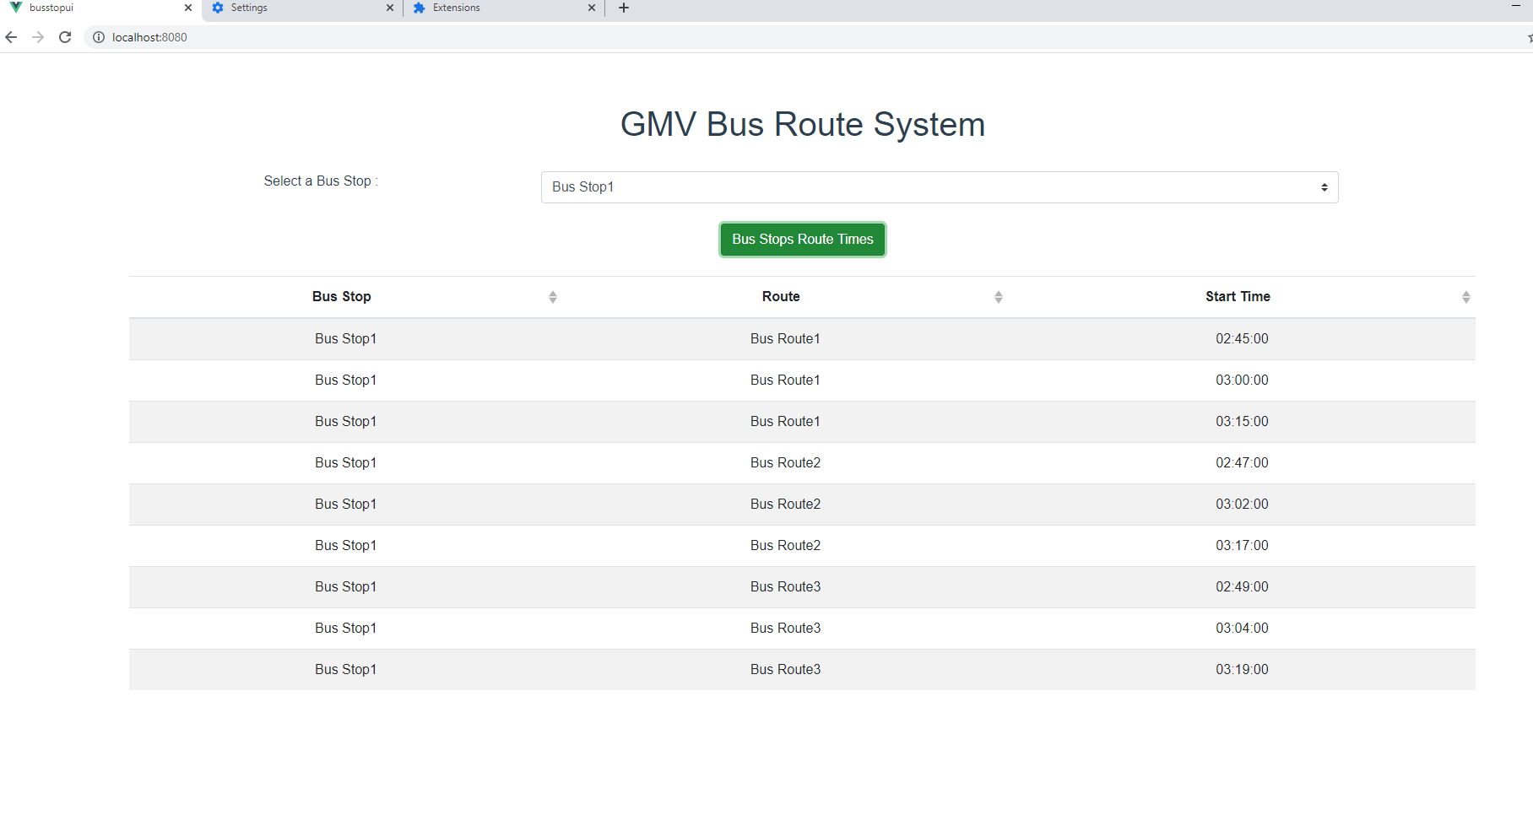

Screen after selected a Bus Stop 2 and then click on the Button.

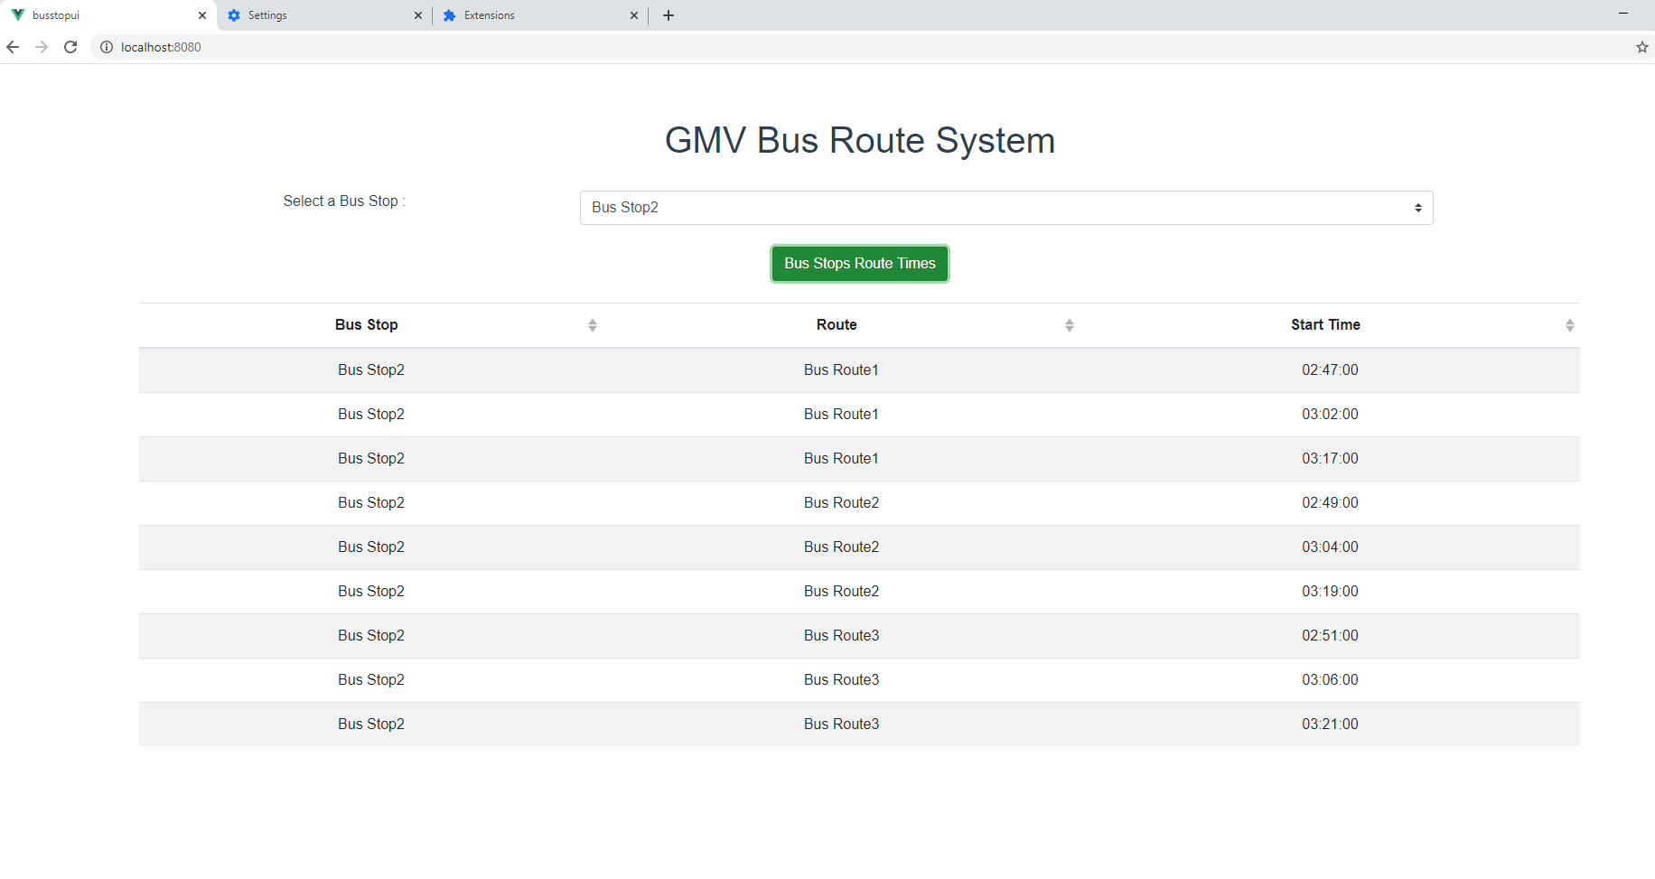

Screen after selected a Bus Stop 3 and then click on the Button.

